**Defect Report**

* **Defect Id: 95**
* **Status: New**
* **Reported by: Bishoy**
* **Asserted to: Omar**
* **Date:**  **17/5/2023**
* **Defect Description: After entering the course name = "DataBase", an InvalidCourseNameException must be thrown but nothing was thrown, and the course code was stored normally. The course name must contain at least one space as mentioned in requirement 1**
* **Steps:**

1. **Open the application**
2. **Enter course name ="DataBase"**
3. **Run the program**

* **Severity: Low**
* **Priority: High**
* **Date Closed: 18/5/2023**
* **Fixed By: Omar**
* **Screenshot for the Defect:**

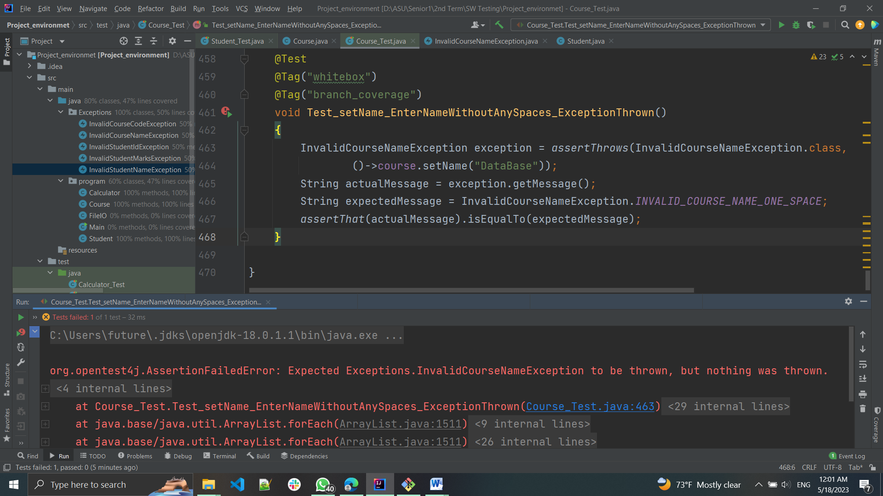

* **Screenshot after fixing:**

